Is my computer lawful?
Mario FUKUOKA, Aleksander BOBIŃSKI, Maciek GRZELCZAK, Patryk CHODOROWSKI,
dr inż. Krzysztof GRUDZIEŃ, dr inż. Zbigniew CHANIECKI

Computer Science

Lodz University of Technology, International Faculty of Engineering

ABSTRACT [up to 1000 characters (incl. spaces)]

The purpose of this project was to identify and solve the problem with legality of software that has risen with the ease of acquiring new software. …. We conducted interviews with people using 5 why method to determine potential problems with legality of software and later on conducted an online survey to verify which of the problems affected largest group of respondents.
- Software description:
  - Database
  - Software Lister
  - License Analyser
- Keywords:
  - Eula
  - License
  - Software
  - Database
  - Lister
  - Analyser

- Introduction
[headers can be named differently, but all required content must be included]
  - Background information
At the beginning of the project we were presented with the following problem:

“Nowadays, the installation of computer software is not a big issue, especially from installation process point of view. We can easily find software with desired features. We can make choice based on analysing advertisements, benchmarking of software or Internet search. We can decide and easily download the computer software. However, the problem arises when we want to know if we can use this software arbitrarily according to the license. What the trial/demo version mean? What changes when we have to buy it or use it without any payment. The misunderstanding of license can lead unlawful use. Even if we install trial type software in a proper way, what should we do after the trial period is finished? Does it have to be uninstalled or just not used any more? Is preservation of the installation on a computer equivalent to misuse of it? The users want to avoid the situation, when the software is not used in compliance to the license agreement yet, the license conditions and agreements are difficult to read and understand. The problem significantly rises when a non-technically skilled person installs computer software. Additionally, pretty often, we can manage the computer system with pre-installed software by a previous user. How to check if the installed software is legal or not? Another issue is when several different people work on the same computer computer. Users are looking for a way to manage owned or newly installed software. They want to be sure, so that if they have to submit the computer to the legal software audit, that everything is in line with the license rules. And what is important, we are living in times, when everything is changing dynamically and our time is very limited…. Most people use computers, but they are not experts in the computer science field.
How to be sure that computer software is legal? How to manage computer system in such way?”

This problem is more complex than it seems. Some licenses may be not legally binding in some countries and not everything is contained inside them. Additionally software can be installed without the users knowledge by other software or viruses. That is why even though there were countless researches into the problem no one was able to provide a universal solution.
It is possible to interpret
[Analytical description of the problem situation presented at the beginning of the project work]
- Present problem (copy paste?)
- Interpretations (presentation + other)
  - Problem finding

To solve the problem we conducted interviews with 15 people with varying age and knowledge about computers. We asked them about [Dokończyć (może podać pytania na których się bazowaliśmy)]

We constructed 10 survey questions based on the responses we got from interviews::

1. In what way do you usually use computer?
2. What operating system do you use?
3. Do you install software on you computer by yourself?
4. Have you ever found software installed on you computer which you didnt recognize?
5. How much is legality of you software on your computer important to you?
6. How much is license of your software important to you?
7. Which problem do you find most important for you in context of the license?
8. How do you look for license of the software installed on your computer?
9. Do you happen to have problems with finding license/guarantee of software which you use?
10. Are you able at any moment to set together the expiration dates of software every software you use/have installed on your computer?

We sent the survey online and got the following responses:
[Zostawić tylko część wyników albo jakoś zmniejszyć zachowując przejrzystość. Jeśli możliwe zostawić tylko wyniki które miały znaczenie i dorzucić wyniki z programu]
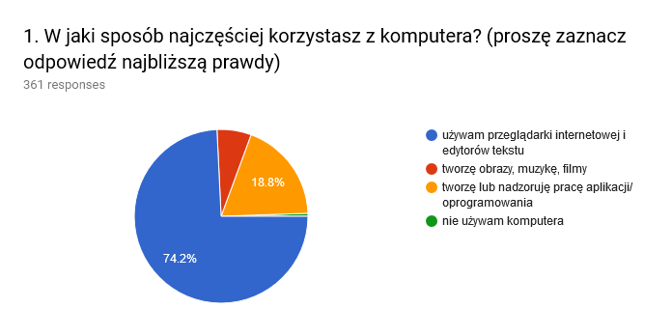
Fig : Results question 1
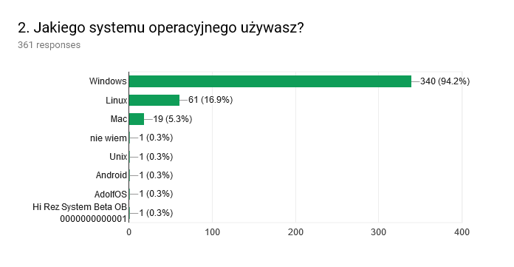
Fig : Results question 2
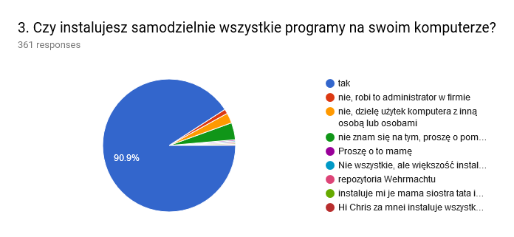
Fig : Results question 3
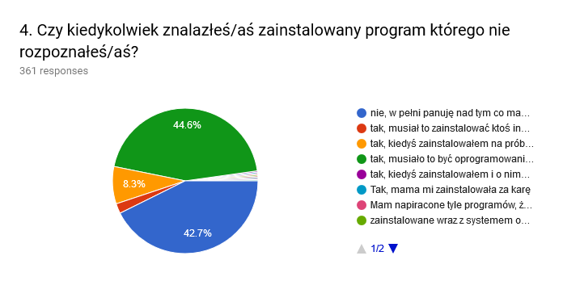
Fig : Results question 4
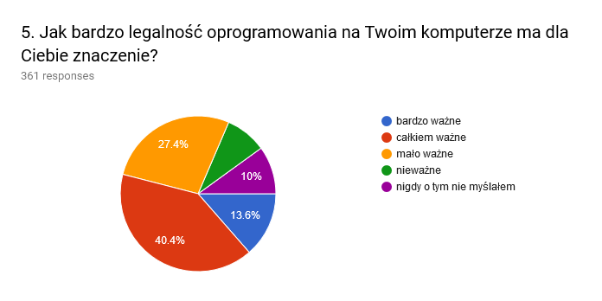
Fig : Results question 5
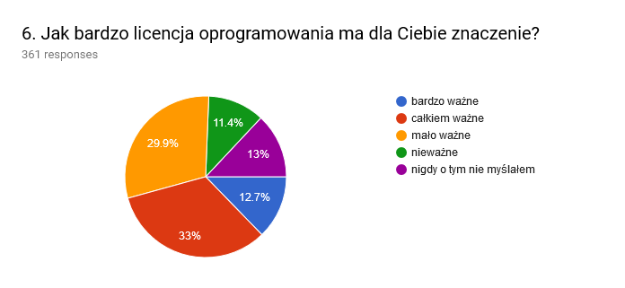
Fig : Results question 6
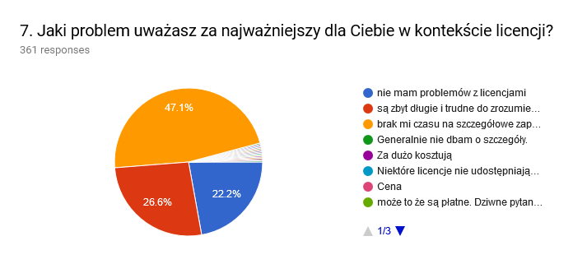
Fig : Results question 7
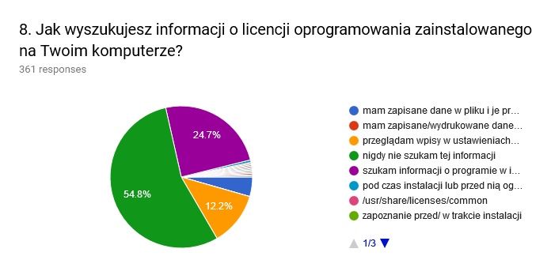
Fig : Results question 8
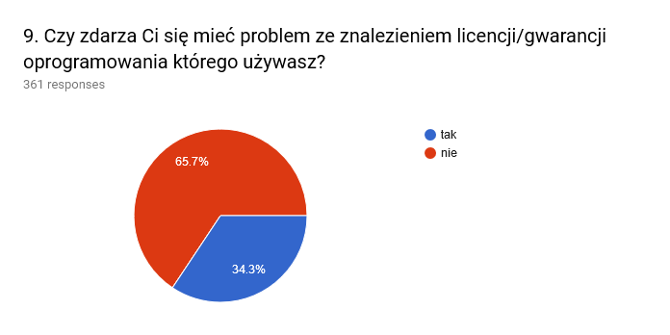
Fig : Results question 9
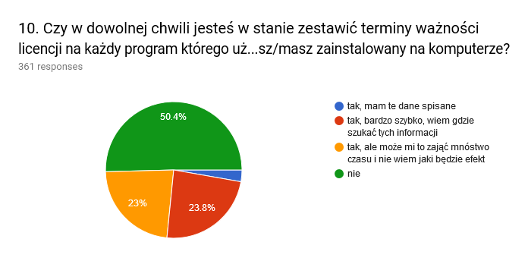
Fig : Results question 10

We wrote a program which showed us how a group of respondents which answered a question in a specific way responded to other questions.

Analysing the results and correlations found by the program we came to a conclusion that people who care about software legality do not know what software they have installed and do not read software licenses.
[The way from the starting point stated above, through detailed research on the general problem to the specific problem description]
- Idea finding
  - State of the art [Rozwinąć]
We looked into solutions to the problem and found 3 existing type of solutions:
- License Analysers
License Analysers take content of a license as input and search for words and phrases that .
- File managers
File managers help you manage files you have installed on your computer.
- License Enforcers
License Enforcers as their name suggest enforce the correct use of the license. They can be added by developers to their software so users will have to use it according to the license.

- License Analysers
- File managers
- License Enforcers (maybe different name)
[Research on existing knowledge and solutions in relation to the specific problem defined above]
  - Innovative ideas [Edytować!!!!]
We came up with many ideas which can help with problems we found:
- Poster showing people they that they do not know everything about licenses and they should read them.
- Movie motivating people to read licenses
- Video game which will raise awareness that writing software is not an easy task and that people should not pirate them.
- Site were people can read a summary of the software written by other users.
- Software which will remind user expiration dates of his trials and subscriptions.
- Motivational program which would keep track how much software on users computer is legal and show how much progress user did.
- Tool for organizing time that will help the user find the time to read licenses.
- License reading course organized by a lawyer.
- Virtual space where user can install software and see if any unwanted software were installed with it and decide whether to install it .
- Doker dla windowsa? Rozdzielenie kompetencji -> lepsza organizacja -> wiemy co jest na kompie (7-8 doker istnieje problemem może okazać się tworzenie obrazów systemu który spełniałby warunki instalacji które miałyby działać, integracja zainstalowanych apek bez naruszania enkapsulacji jest niemożliwa, poza tym może okazać się trudna; 6-7 każdy program na kompie ma swoją szklaną kulę w której pracuje i nie widzi nic poza nią. W przypadku stwierdzenia nielegalności można usunąć kulę nie zostawiając po niej okruchów)
- Software in which you can write who you are it shows you which parts of the license are interesting to you.
- Quiz which will show people what they do not know about licenses
- Site were you can ask if you can do something with the software and people who read its license can tell you.

- List of ideas and explanation how they help
[Ideas developed by your team, adding new value to better address the stated problem, possibly leading to more effective solutions]
  - Main idea selection and justification
- Make chart with ideas [innovation, difficulty]
- Selection:
  - Software Lister
  - License Analyser
  - Database
- Justification:
  - Innovation to difficulty comparison
  - Compatibility with each other

[Which of the above ideas your team finds the most worth developing and why.]
- Solution implementation
  - Detailed solution description
Our program is written in python. It uses the following libraries:
- requests
- beatifulsoup4
- appJar

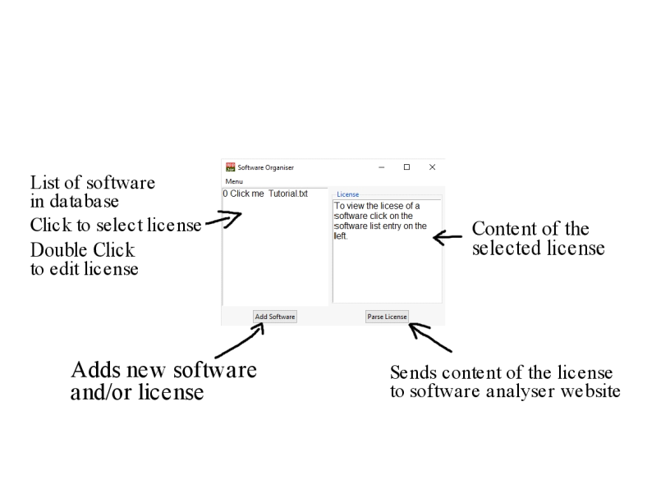
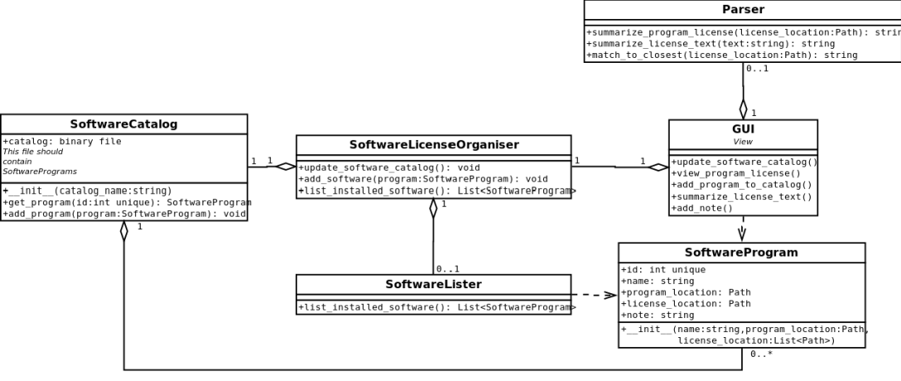
Fig : UML

- Python + Why
- UML
- Documentation
Fig : Guide to using software

[Details of putting the selected idea into life e.g. in form of a material or virtual prototype]
  - Ways of verification
- Survey
[How your team plans to verify (or have already verified) if your solution effectively solves the problem]
- Conclusions and perspectives
- Did we finish? (If not write what is missing)
- Strengths
- Weaknesses
- Features that can be implemented
[Summarize your work, highlighting strengths and weaknesses of its results. How do you see a potential follow-up of the project?]

Acknowledgements (optional)
…………………………………..……………………………………………..… …………………………………………………………….………………………
References
- Borzemski L.: An algorithm for a certain reliability problem. Proc. 7th Int. Conf. on Systems Engineering. Las Vegas, University of Nevada, 1990, s. 242.
- Eimer C.: Plasticity of polycrystal. Archives of Mechanics. Vol. 29, No. 5, 1977,
ss. 687-704.
- Nowacki W.: Theory of elasticity. PWN, Warszawa 1970.

